Tabla 1. Baseline characteristics of individuals developing a first CV during follow-up by age group and sex.

|  |  |  |  |  |  |  |  |  |  |  |
| --- | --- | --- | --- | --- | --- | --- | --- | --- | --- | --- |
|  |  | **[ALL]** | **Y (< 35 y)** | **EA (35-55/65 y)** | **MA (55/65-65/70)** | **YO (65/70-75 y)** | **MVO (> 75y)** | **p value age** | **N** | **p value sex** |
| **Number (%)** | **Men** | 137338 (53.3%) | 1754 (57.5%) | 29066 (50.3%) | 31897 (71.8%) | 34914 (68.7%) | 39707 (39.0%) | <0.001 | 137338 | <0.001 |
|  | **Women** | 120567 (46.7%) | 1297 (42.5%) | 28724 (49.7%) | 12547 (28.2%) | 15884 (31.3%) | 62115 (61.0%) | <0.001 |  |  |
| **Age (Years)** | **Men** | 65.8 (13.4) | 31.9 (2.17) | 47.8 (5.10) | 60.2 (2.86) | 70.1 (2.97) | 81.3 (4.59) | <0.001 | 137338 | <0.001 |
|  | **Women** | 72.7 (13.2) | 31.6 (2.21) | 55.0 (7.62) | 67.6 (1.49) | 72.8 (1.38) | 82.7 (5.11) | <0.001 | 120567 |  |
| **Smoker** | **Men** | 37087 (35.9%) | 652 (64.6%) | 12931 (65.7%) | 11128 (46.4%) | 7983 (28.5%) | 4393 (14.4%) | <0.001 | 103307 | <0.001 |
|  | **Women** | 9554 (10.3%) | 367 (44.0%) | 6902 (32.2%) | 810 (7.90%) | 554 (4.29%) | 921 (1.95%) | <0.001 | 92767 |  |
| **Type 2 diabetes** | **Men** | 31605 (23.0%) | **24 (1.37%)\*** | 3446 (11.9%) | 7547 (23.7%) | 10257 (29.4%) | 10331 (26.0%) | <0.001 | 137338 | <0.001 |
|  | **Women** | 26459 (21.9%) | **33 (2.54%)** | 4477 (15.6%) | 3216 (25.6%) | 4347 (27.4%) | 14386 (23.2%) | <0.001 | 120567 |  |
| **Total cholesterol (mg/dl)** | **Men** | 201 (40.0) | 199 (51.5) | **217 (45.9)\*** | 209 (41.2) | 199 (37.3) | 192 (36.2) | <0.001 | 65667 | <0.001 |
|  | **Women** | 211 (38.5) | 184 (37.3) | **219 (41.2)** | 214 (38.2) | 212 (37.0) | 208 (37.3) | <0.001 | 67030 |  |
| **HDL cholesterol (mg/dl)** | **Men** | 49.0 (13.0) | 45.8 (12.9) | 45.8 (13.0) | 47.9 (12.7) | 49.6 (13.0) | 50.4 (13.0) | <0.001 | 52785 | <0.001 |
|  | **Women** | 57.2 (14.4) | 54.7 (16.1) | 56.3 (14.7) | 56.7 (14.2) | 56.9 (13.8) | 57.8 (14.5) | <0.001 | 54536 |  |
| **LDL cholesterol (mg/dl)** | **Men** | 125 (34.6) | 126 (39.3) | **137 (37.9)ns** | **130 (35.8)ns** | 124 (33.3) | 119 (32.0) | <0.001 | 52785 | <0.001 |
|  | **Women** | 129 (34.0) | 111 (34.7) | **137 (36.4)** | **130 (34.3)** | 128 (32.9) | 126 (32.8) | <0.001 | 54536 |  |
| **Statin treatment** | **Men** | 40934 (29.8%) | **81 (4.62%)\*** | 5640 (19.4%) | 10804 (33.9%) | 13476 (38.6%) | 10933 (27.5%) | <0.001 | 137338 | <0.001 |
|  | **Women** | 37775 (31.3%) | **37 (2.85%)** | 8156 (28.4%) | 5184 (41.3%) | 6562 (41.3%) | 17836 (28.7%) | <0.001 | 120567 |  |
| **Hypertension** | **Men** | 63316 (46.1%) | 104 (5.93%) | 6677 (23.0%) | 13252 (41.5%) | 19285 (55.2%) | 23998 (60.4%) | <0.001 | 137338 | <0.001 |
|  | **Women** | 72315 (60.0%) | 59 (4.55%) | 10608 (36.9%) | 7626 (60.8%) | 10675 (67.2%) | 43347 (69.8%) | <0.001 | 120567 |  |
| **Anti-hipertensive meds** | **Men** | 76958 (56.0%) | **218 (12.4%)ns** | 9540 (32.8%) | 17054 (53.5%) | 22969 (65.8%) | 27177 (68.4%) | <0.001 | 137338 | <0.001 |
|  | **Women** | 82062 (68.1%) | **140 (10.8%)** | 13847 (48.2%) | 8933 (71.2%) | 11979 (75.4%) | 47163 (75.9%) | <0.001 | 120567 |  |
| **Systolic Blood Pressure (mmHg)** | **Men** | 136 (15.9) | 128 (16.0) | 134 (16.1) | 136 (15.9) | **137 (15.8)ns** | 137 (15.8) | <0.001 | 72723 | 0.058 |
|  | **Women** | 136 (16.6) | 118 (13.3) | 132 (16.8) | 135 (15.7) | **137 (15.9)** | 138 (16.5) | <0.001 | 75088 |  |
| **Diastolic Blood Pressure (mmHg)** | **Men** | 76.5 (9.97) | 78.2 (12.4) | 82.2 (10.5) | 79.6 (9.50) | **76.3 (9.19)\*** | 73.1 (9.25) | <0.001 | 72723 | <0.001 |
|  | **Women** | 75.5 (9.69) | 72.7 (10.5) | 78.9 (9.98) | 77.1 (9.22) | **76.0 (9.27)** | 73.9 (9.42) | <0.001 | 75088 |  |
| **Triglycerides (mg/dl)** | **Men** | 146 (103) | 182 (197) | 197 (163) | 165 (118) | 138 (77.9) | 121 (64.8) | <0.001 | 57362 | <0.001 |
|  | **Women** | 135 (73.8) | 112 (56.7) | 143 (99.6) | 139 (74.0) | 137 (68.2) | 130 (62.6) | <0.001 | 58255 |  |
| **Triglyc. > 150 mg/dl** | **Men** | 18987 (33.1%) | 82 (37.6%) | 3816 (52.3%) | 5427 (41.6%) | 5488 (31.0%) | 4174 (21.8%) | <0.001 |  | <0.001 |
|  | **Women** | 17087 (29.3%) | 36 (17.6%) | 3795 (32.4%) | 2177 (31.8%) | 2757 (31.3%) | 8322 (27.1%) | <0.001 | 58255 |  |
| **Remnant cholesterol (mg/dl)** | **Men** | 26.7 (15.2) | 28.5 (20.9) | 32.8 (18.1) | 29.4 (16.1) | 26.1 (14.3) | 23.1 (12.9) | <0.001 | 52785 | <0.001 |
|  | **Women** | 25.9 (14.0) | 21.1 (13.3) | 26.4 (15.6) | 26.7 (14.5) | 26.5 (13.7) | 25.3 (13.2) | <0.001 | 54536 |  |
| **Atherogenic dyslipidemia** | **Men** | 6396 (12.3%) | 33 (17.7%) | 1420 (22.6%) | 1811 (15.4%) | 1733 (10.6%) | 1399 (8.06%) | <0.001 | 52011 | <0.001 |
|  | **Women** | 8656 (16.1%) | 24 (14.8%) | 2029 (19.0%) | 1133 (17.8%) | 1384 (16.7%) | 4086 (14.5%) | <0.001 | 53715 |  |
| **Antiplatelet medication** | **Men** | 34617 (25.2%) | **65 (3.71%)ns** | 3160 (10.9%) | **6971 (21.9%)\*** | 10598 (30.4%) | 13823 (34.8%) | <0.001 | 137338 | 0.002 |
|  | **Women** | 29742 (24.7%) | **38 (2.93%)** | 4084 (14.2%) | **2892 (23.0%)** | 4079 (25.7%) | 18649 (30.0%) | <0.001 | 120567 |  |
| **Family history of CVD** | **Men** | 403 (0.29%) | 10 (0.57%) | 144 (0.50%) | 127 (0.40%) | 79 (0.23%) | 43 (0.11%) | <0.001 | 137338 | 0.307 |
|  | **Women** | 327 (0.27%) | 5 (0.39%) | 170 (0.59%) | 53 (0.42%) | 33 (0.21%) | 66 (0.11%) | <0.001 | 120567 |  |
| **Body mass index , BMI (kg/m2)** | **Men** | 28.9 (4.34) | 28.0 (5.94) | 29.7 (5.31) | 29.4 (4.57) | 29.1 (4.21) | 28.2 (3.82) | <0.001 | 43917 | <0.001 |
|  | **Women** | 30.2 (5.62) | 26.8 (6.43) | 30.9 (6.57) | 31.2 (5.75) | 31.1 (5.51) | 29.5 (5.10) | <0.001 | 43868 |  |
| **BMI > 30 kg/m2** | **Men** | 15577 (35.5%) | 47 (28.3%) | 2118 (42.9%) | 3646 (40.1%) | 5160 (37.0%) | 4606 (29.2%) | <0.001 | 43917 | <0.001 |
|  | **Women** | 20657 (47.1%) | 75 (25.6%) | 4194 (51.4%) | 2839 (53.3%) | 3733 (53.3%) | 9816 (42.5%) | <0.001 | 43868 |  |
| **Non-alcoholic fatty liver** | **Men** | 1689 (1.23%) | 9 (0.51%) | 382 (1.31%) | 571 (1.79%) | 461 (1.32%) | 266 (0.67%) | <0.001 | 137338 | 0.001 |
|  | **Women** | 1307 (1.08%) | 4 (0.31%) | 448 (1.56%) | 257 (2.05%) | 200 (1.26%) | 398 (0.64%) | <0.001 | 120567 |  |
| **eGFR (CKD-EPI) mL/min/1.73m2** | **Men** | 73.8 (16.3) | 87.2 (9.64) | 84.9 (10.0) | 80.7 (12.7) | 74.4 (14.6) | 64.7 (16.5) | <0.001 | 65654 | <0.001 |
|  | **Women** | 69.0 (18.0) | 87.4 (9.09) | 81.6 (12.6) | 75.9 (14.6) | 71.5 (16.1) | 61.7 (17.4) | <0.001 | 66743 |  |
| **eGFR ≤ 60 mL/min/1.73m2** | **Men** | 13089 (19.9%) | 7 (2.33%) | 219 (2.67%) | 1014 (7.09%) | 3286 (16.4%) | 8563 (37.5%) | <0.001 |  | <0.001 |
|  | **Women** | 20371 (30.5%) | 6 (1.63%) | 885 (6.48%) | 1097 (14.4%) | 2324 (23.7%) | 16059 (45.5%) | <0.001 |  |  |
| **Urinary Albumin to Creatinine (UACR), mg/gr** | **Men** | 46.0 (171) | 45.0 (144) | 53.2 (220) | 45.6 (176) | 40.9 (154) | 49.0 (168) | 0.850 | 18365 | <0.001 |
|  | **Women** | 35.5 (137) | 61.9 (200) | 37.0 (159) | 33.5 (165) | 32.0 (123) | 36.6 (125) | 0.840 | 17715 |  |
| **UACR > 30 mg/gr** | **Men** | 3874 (21.1%) | 3 (12.5%) | 367 (21.1%) | 814 (19.6%) | 1163 (19.0%) | 1527 (24.1%) | <0.001 | 18365 | <0.001 |
|  | **Women** | 2913 (16.4%) | 3 (18.8%) | 437 (14.3%) | 275 (12.4%) | 439 (14.8%) | 1759 (18.6%) | <0.001 |  |  |
| **High risk alcohol consumption** | **Men** | 2317 (5.45%) | 11 (5.07%) | 503 (9.72%) | 762 (8.65%) | 669 (5.05%) | 372 (2.47%) | <0.001 | 42502 | <0.001 |
|  | **Women** | 303 (0.72%) | 1 (0.52%) | 136 (1.69%) | 38 (0.76%) | 37 (0.56%) | 91 (0.40%) | <0.001 | 42367 |  |
| **Deprivation Index (Q5)** | **Men** | 17967 (13.1%) | 309 (17.6%) | 4838 (16.6%) | 4289 (13.4%) | 4590 (13.1%) | 3941 (9.93%) | 0.000 | 137338 | <0.001 |
|  | **Women** | 14512 (12.0%) | 207 (16.0%) | 4348 (15.1%) | 1840 (14.7%) | 2271 (14.3%) | 5846 (9.41%) | <0.001 |  |  |

Table 2. Cardiovascular events and distribution by territory according age group

|  |  |  |  |  |  |  |
| --- | --- | --- | --- | --- | --- | --- |
|  | **[ALL]** | **Y** | **EA** | **MA** | **YO** | **MVO** |
|  | N=257905 | N=3051 (1.2%) | N=57790 (22.4%) | N=44444 (17.2%) | N=50798 (17.9%) | N=101822 (39.5%) |
| **Coronary** | 73013 (28.3%) | 1191 (39.0%) | 23159 (40.1%) | 15702 (35.3%) | 14356 (28.3%) | 18605 (18.3%) |
| **Cerebrovascular** | 64076 (24.8%) | 978 (32.1%) | 15282 (26.4%) | 10563 (23.8%) | 12606 (24.8%) | 24647 (24.2%) |
| **Peripheral** | 43660 (16.9%) | 497 (16.3%) | 10686 (18.5%) | 9745 (21.9%) | 10496 (20.7%) | 12236 (12.0%) |
| **Heart Failure** | 77156 (29.9%) | 385 (12.6%) | 8663 (15.0%) | 8434 (19.0%) | 13340 (26.3%) | 46334 (45.5%) |

Figure 1. Distribution by territory of incident CV events according sex and age group (left) or by age group and sex (right)

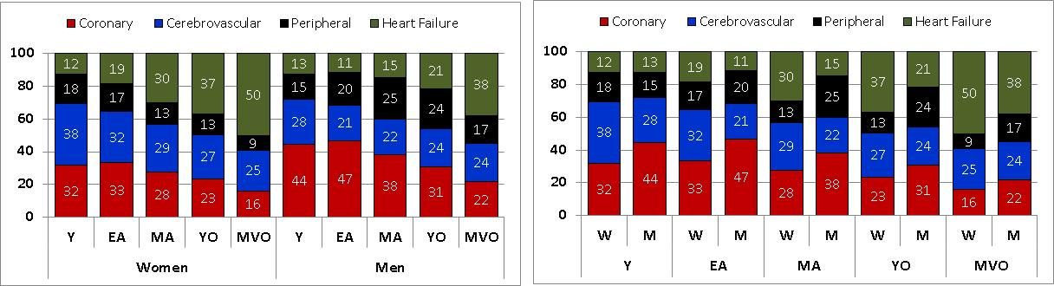

Table 3. First manifestation of cardiovascular disease by age group and sex

|  |  |  |  |  |  |  |  |  |  |  |  |  |
| --- | --- | --- | --- | --- | --- | --- | --- | --- | --- | --- | --- | --- |
|  | Women |  |  |  |  |  | Men |  |  |  |  |  |
|  | **[ALL]** | **Y** | **EA** | **MA** | **YO** | **MVO** | **[ALL]** | **Y** | **EA** | **MA** | **YO** | **MVO** |
|  | *N=120567* | *N=1297* | *N=28724* | *N=12547* | *N=15884* | *N=62115* | *N=137338* | *N=1754* | *N=29066* | *N=31897* | *N=34914* | *N=39707* |
| HF-CONGESTIVE | **20045 (16.6%)** | 77 (5.94%) | 2154 (7.50%) | 1404 (11.2%) | **2276 (14.3%)** | **14134 (22.8%)** | 13944 (10.2%) | 96 (5.47%) | 1449 (4.99%) | 2000 (6.27%) | 3207 (9.19%) | **7192 (18.1%)** |
| HF-OTHERS | **26370 (21.9%)** | 83 (6.40%) | 3210 (11.2%) | **2373 (18.9%)** | **3576 (22.5%)** | **17128 (27.6%)** | **16797 (12.2%)** | 129 (7.35%) | 1850 (6.36%) | 2657 (8.33%) | **4281 (12.3%)** | **7880 (19.8%)** |
| PAD | 10030 (8.32%) | 95 (7.32%) | 3033 (10.6%) | 1077 (8.58%) | 1397 (8.80%) | 4428 (7.13%) | **23867 (17.4%)** | 149 (8.49%) | **4913 (16.9%)** | **6654 (20.9%)** | **6745 (19.3%)** | **5406 (13.6%)** |
| PAD-CAROTID | 2866 (2.38%) | 15 (1.16%) | 969 (3.37%) | 455 (3.63%) | 475 (2.99%) | 952 (1.53%) | 3799 (2.77%) | 12 (0.68%) | 480 (1.65%) | 978 (3.07%) | 1311 (3.75%) | 1018 (2.56%) |
| PER-REV | 1275 (1.06%) | 124 (9.56%) | 749 (2.61%) | 107 (0.85%) | 120 (0.76%) | 175 (0.28%) | 1823 (1.33%) | 102 (5.82%) | 542 (1.86%) | 474 (1.49%) | 448 (1.28%) | 257 (0.65%) |
| TIA | 13869 (11.5%) | **202 (15.6%)** | **4419 (15.4%)** | **1635 (13.0%)** | 1766 (11.1%) | 5847 (9.41%) | 10841 (7.89%) | 172 (9.81%) | 2046 (7.04%) | 2539 (7.96%) | 2864 (8.20%) | 3220 (8.11%) |
| STROKE-ISCH | **15833 (13.1%)** | **200 (15.4%)** | **3548 (12.4%)** | **1715 (13.7%)** | **2210 (13.9%)** | **8160 (13.1%)** | **16793 (12.2%)** | **202 (11.5%)** | 3248 (11.2%) | 3645 (11.4%) | **4525 (13.0%)** | 5173 (13.0%) |
| STROKE-HEM | 3066 (2.54%) | 86 (6.63%) | 1056 (3.68%) | 297 (2.37%) | 354 (2.23%) | 1273 (2.05%) | 3546 (2.58%) | 110 (6.27%) | 885 (3.04%) | 718 (2.25%) | 865 (2.48%) | 968 (2.44%) |
| CEREBRAL-REV | 76 (0.06%) | 2 (0.15%) | 55 (0.19%) | 6 (0.05%) | 9 (0.06%) | 4 (0.01%) | 52 (0.04%) | 4 (0.23%) | 25 (0.09%) | 8 (0.03%) | 13 (0.04%) | 2 (0.01%) |
| CHD-NON | 10088 (8.37%) | **209 (16.1%)** | **3332 (11.6%)** | 1281 (10.2%) | 1426 (8.98%) | 3840 (6.18%) | 14887 (10.8%) | **244 (13.9%)** | **3325 (11.4%)** | **4027 (12.6%)** | 3932 (11.3%) | 3359 (8.46%) |
| ANGOR | 8776 (7.28%) | 67 (5.17%) | 3194 (11.1%) | 1280 (10.2%) | 1255 (7.90%) | 2980 (4.80%) | 11561 (8.42%) | 134 (7.64%) | 2970 (10.2%) | 3232 (10.1%) | 2984 (8.55%) | 2241 (5.64%) |
| MI | 8103 (6.72%) | 129 (9.95%) | 2950 (10.3%) | 897 (7.15%) | 1002 (6.31%) | 3125 (5.03%) | **19057 (13.9%)** | **396 (22.6%)** | **7287 (25.1%)** | **4903 (15.4%)** | 3601 (10.3%) | 2870 (7.23%) |
| CORONARY-REV | 170 (0.14%) | 8 (0.62%) | 55 (0.19%) | 20 (0.16%) | 18 (0.11%) | 69 (0.11%) | 371 (0.27%) | 4 (0.23%) | 46 (0.16%) | 62 (0.19%) | 138 (0.40%) | 121 (0.30%) |

**Table 4. Incidence of first cardiovascular events by age and sex**

|  |  |  |  |  |  |
| --- | --- | --- | --- | --- | --- |
| **Age-group** | **N** | **Events** | **Person-time (year)** | **Incidence rate (%-year)** |  |
| **WOMEN** |  |  |  |  |  |
| All | 2101333 | 120567 | 14030815 | 0.859 |  |
| Y | 398422 | 1297 | 2782552.8 | 0.047 |  |
| EA | 1207673 | 28724 | 8321632.5 | 0.345 |  |
| MA | 129453 | 12547 | 851430.1 | 1.474 |  |
| YO | 104885 | 15884 | 661674.7 | 2.401 |  |
| MVO | 260900 | 62115 | 1413524.9 | 4.394 |  |
| **MEN** |  |  |  |  |  |
| All | 1951633 | 137338 | 12916654 | 1.063 |  |
| Y | 418713 | 1754 | 2920925.7 | 0.060 |  |
| EA | 928715 | 29066 | 6368380.1 | 0.456 |  |
| MA | 281426 | 31897 | 1819869.6 | 1.753 |  |
| YO | 182729 | 34914 | 1101114.4 | 3.171 |  |
| MVO | 140050 | 39707 | 706364.0 | 5.621 |  |

Figure 3. Sex differences in the first territory affected by cardiovascular disease by age group

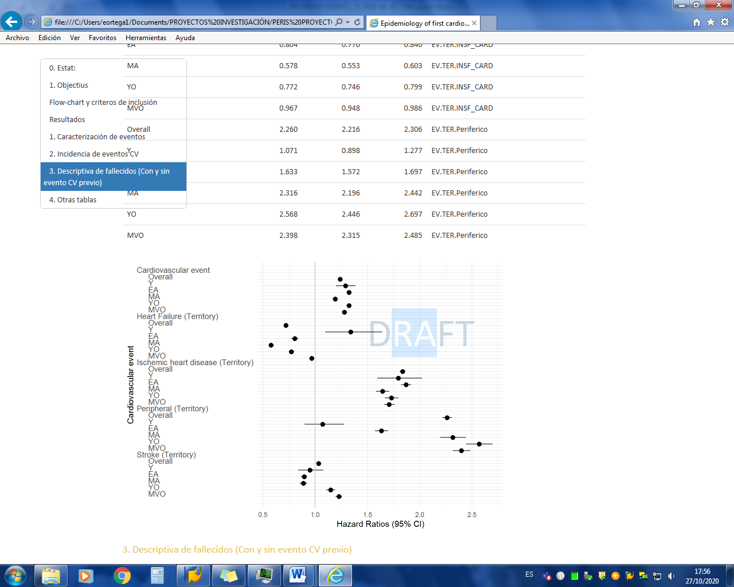

**Supplementary tables and figures**

**Tabla códigos y diagnósticos**

**Supplementary Table 1.** Baseline characteristics of individuals with incident first CV during follow-up by age group

|  |  |  |  |  |  |  |  |  |
| --- | --- | --- | --- | --- | --- | --- | --- | --- |
| Columna1 | [ALL] | Y | EA | MA | YO | MVO |  | N |
| Number % | 257914 | 3051 (1.2%) | 57793(22.4%) | 44444(17.2%) | 50798(19.7%) | 101828(39.5%) |  | 257905 |
| Age (Years) | 69.0 (13.8) | 31.8 (2.19) | 51.4 (7.40) | 62.3 (4.18) | 70.9 (2.87) | 82.2 (4.96) |  | 257905 |
| Male sex | 137338 (53.3%) | 1754 (57.5%) | 29066 (50.3%) | 31897 (71.8%) | 34914 (68.7%) | 39707 (39.0%) |  | 257905 |
| Smoker | 46641 (23.8%) | 1019 (55.3%) | 19833 (48.2%) | 11938 (34.9%) | 8537 (20.8%) | 5314 (6.82%) |  | 196074 |
| Type 2 diabetes | 58064 (22.5%) | 57 (1.87%) | 7923 (13.7%) | 10763 (24.2%) | 14604 (28.7%) | 24717 (24.3%) |  | 257905 |
| Total cholesterol (mg/dl) | 206 (39.6) | 191 (44.9) | 218 (43.0) | 211 (40.3) | 203 (37.6) | 202 (37.7) |  | 132697 |
| HDL cholesterol (mg/dl) | 53.2 (14.3) | 50.2 (15.2) | 52.4 (15.0) | 51.0 (13.9) | 52.1 (13.7) | 55.0 (14.4) |  | 107321 |
| LDL cholesterol (mg/dl) | 127 (34.4) | 119 (37.7) | 137 (37.0) | 130 (35.3) | 125 (33.2) | 123 (32.6) |  | 107321 |
| Statin treatment | 78709 (30.5%) | 118 (3.87%) | 13796 (23.9%) | 15988 (36.0%) | 20038 (39.4%) | 28769 (28.3%) |  | 257905 |
| Hypertension | 135631 (52.6%) | 163 (5.34%) | 17285 (29.9%) | 20878 (47.0%) | 29960 (59.0%) | 67345 (66.1%) |  | 257905 |
| Hypotensive medication | 159020 (61.7%) | 358 (11.7%) | 23387 (40.5%) | 25987 (58.5%) | 34948 (68.8%) | 74340 (73.0%) |  | 257905 |
| Systolic Blood Pressure (mmHg) | 136 (16.2) | 122 (15.4) | 133 (16.6) | 136 (15.9) | 137 (15.9) | 137 (16.2) |  | 147811 |
| Diastolic Blood Pressure (mmHg) | 76.0 (9.84) | 75.0 (11.7) | 80.2 (10.3) | 78.7 (9.48) | 76.2 (9.22) | 73.6 (9.36) |  | 147811 |
| Triglycerides (mg/dl) | 140 (89.6) | 148 (151) | 163 (130) | 156 (106) | 138 (74.9) | 126 (63.6) |  | 115617 |
| > 150 mg/dl | 36074 (31.2%) | 118 (27.9%) | 7611 (40.0%) | 7604 (38.3%) | 8245 (31.1%) | 12496 (25.1%) |  | 115617 |
| Remnant cholesterol (mg/dl) | 26.3 (14.6) | 24.9 (18.0) | 28.8 (16.9) | 28.5 (15.6) | 26.3 (14.1) | 24.4 (13.1) |  | 107321 |
| Atherogenic dyslipidemia: Si | 15052 (14.2%) | 57 (16.4%) | 3449 (20.4%) | 2944 (16.2%) | 3117 (12.6%) | 5485 (12.0%) |  | 105726 |
| Antiplatelet medication | 64359 (25.0%) | 103 (3.38%) | 7244 (12.5%) | 9863 (22.2%) | 14677 (28.9%) | 32472 (31.9%) |  | 257905 |
| Family history of CVD | 730 (0.28%) | 15 (0.49%) | 314 (0.54%) | 180 (0.41%) | 112 (0.22%) | 109 (0.11%) |  | 257905 |
| Body mass index (kg/m2): | 29.5 (5.06) | 27.2 (6.28) | 30.5 (6.16) | 30.1 (5.12) | 29.7 (4.78) | 29.0 (4.67) |  | 87785 |
| BMI > 30 kg/m2 | 36234 (41.3%) | 122 (26.6%) | 6312 (48.2%) | 6485 (45.0%) | 8893 (42.4%) | 14422 (37.1%) |  | 87785 |
| Non-alcoholic fatty liver | 2996 (1.16%) | 13 (0.43%) | 830 (1.44%) | 828 (1.86%) | 661 (1.30%) | 664 (0.65%) |  | 257905 |
| Glomerular Filtration (CKD-EPI) | 71.4 (17.3) | 87.3 (9.33) | 82.8 (11.8) | 79.0 (13.6) | 73.4 (15.2) | 62.9 (17.1) |  | 132397 |
| CKD-EPI ≤ 60 ml/min | 33460 (25.3%) | 13 (1.95%) | 1104 (5.05%) | 2111 (9.64%) | 5610 (18.8%) | 24622 (42.3%) |  | 132397 |
| Albumin / Creatinine | 40.9 (155) | 51.8 (166) | 42.9 (183) | 41.4 (172) | 38.0 (145) | 41.6 (144) |  | 36080 |
| UACR > 30 mg/gr | 6787 (18.8%) | 6 (15.0%) | 804 (16.8%) | 1089 (17.1%) | 1602 (17.7%) | 3286 (20.8%) |  | 36080 |
| High risk alcohol | 2620 (3.09%) | 12 (2.94%) | 639 (4.83%) | 800 (5.80%) | 706 (3.56%) | 463 (1.23%) |  | 84869 |
| QMEDEA U5 | 32479 (12.6%) | 516 (16.9%) | 9186 (15.9%) | 6129 (13.8%) | 6861 (13.5%) | 9787 (9.61%) |  | 257905 |

**Supplementary table 2. Cardiovascular events by territory affected sex and age group.**

|  |  |  |  |  |  |  |  |  |  |  |  |  |
| --- | --- | --- | --- | --- | --- | --- | --- | --- | --- | --- | --- | --- |
|  | Women | Y | EA | MA | YO | MVO | Men | Y | EA | MA | YO | MVO |
|  | *N=120567* | *N=1297* | *N=28724* | *N=12547* | *N=15884* | *N=62115* | *N=137338* | *N=1754* | *N=29066* | *N=31897* | *N=34914* | *N=39707* |
| Heart Failure | 46415 (38,5%) | 160 (12,3%) | 5364 (18,7%) | 3777 (30,1%) | 5852 (36,8%) | 31262 (50,3%) | 30741 (22,4%) | 225 (12,8%) | 3299 (11,4%) | 4657 (14,6%) | 7488 (21,4%) | 15072 (38,0%) |
| Peripheral | 14171 (11,8%) | 234 (18,0%) | 4751 (16,5%) | 1639 (13,1%) | 1992 (12,5%) | 5555 (8,94%) | 29489 (21,5%) | 263 (15,0%) | 5935 (20,4%) | 8106 (25,4%) | 8504 (24,4%) | 6681 (16,8%) |
| Cerebro vascular | 32844 (27,2%) | 490 (37,8%) | 9078 (31,6%) | 3653 (29,1%) | 4339 (27,3%) | 15284 (24,6%) | 31232 (22,7%) | 488 (27,8%) | 6204 (21,3%) | 6910 (21,7%) | 8267 (23,7%) | 9363 (23,6%) |
| Coronary | 27137 (22,5%) | 413 (31,8%) | 9531 (33,2%) | 3478 (27,7%) | 3701 (23,3%) | 10014 (16,1%) | 45876 (33,4%) | 778 (44,4%) | 13628 (46,9%) | 12224 (38,3%) | 10655 (30,5%) | 8591 (21,6%) |

Suplementary figure 1. Number of individuals suffering a first cardiovascular event and territory affected. Total (1A), women (1B), and men (1C)

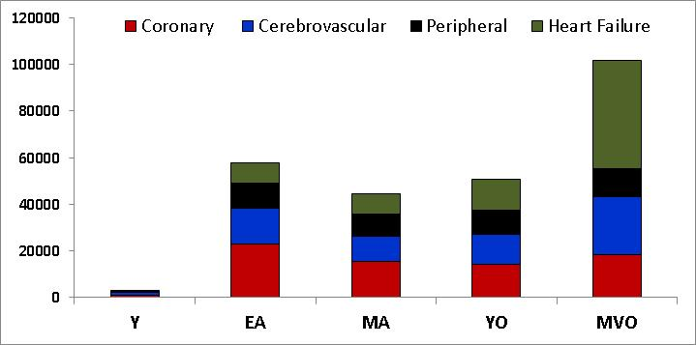.

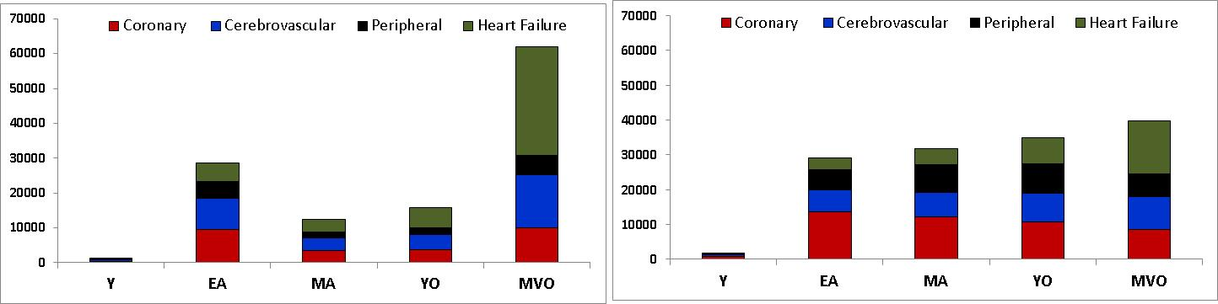

Supplementary figure 2. First manifestation of cardiovascular disease by age and sex

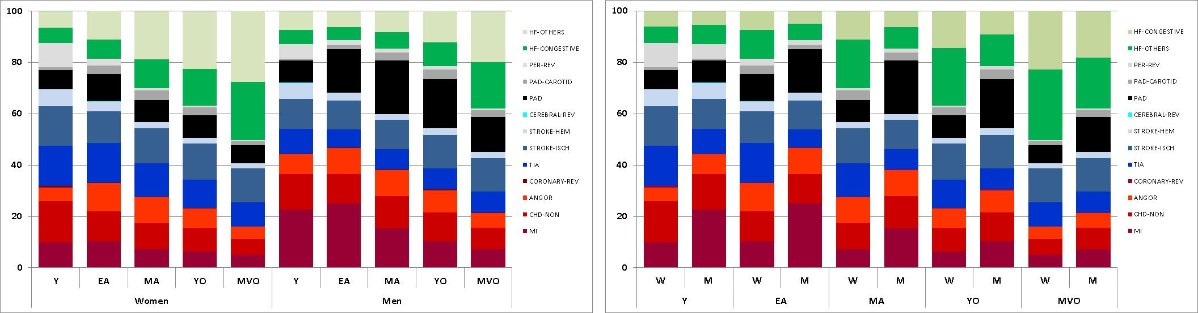

Suplemmentary figure 3. Sería las lineas de incidencia durante los 7 años de segumiento.

Suplemmentary Table 2.

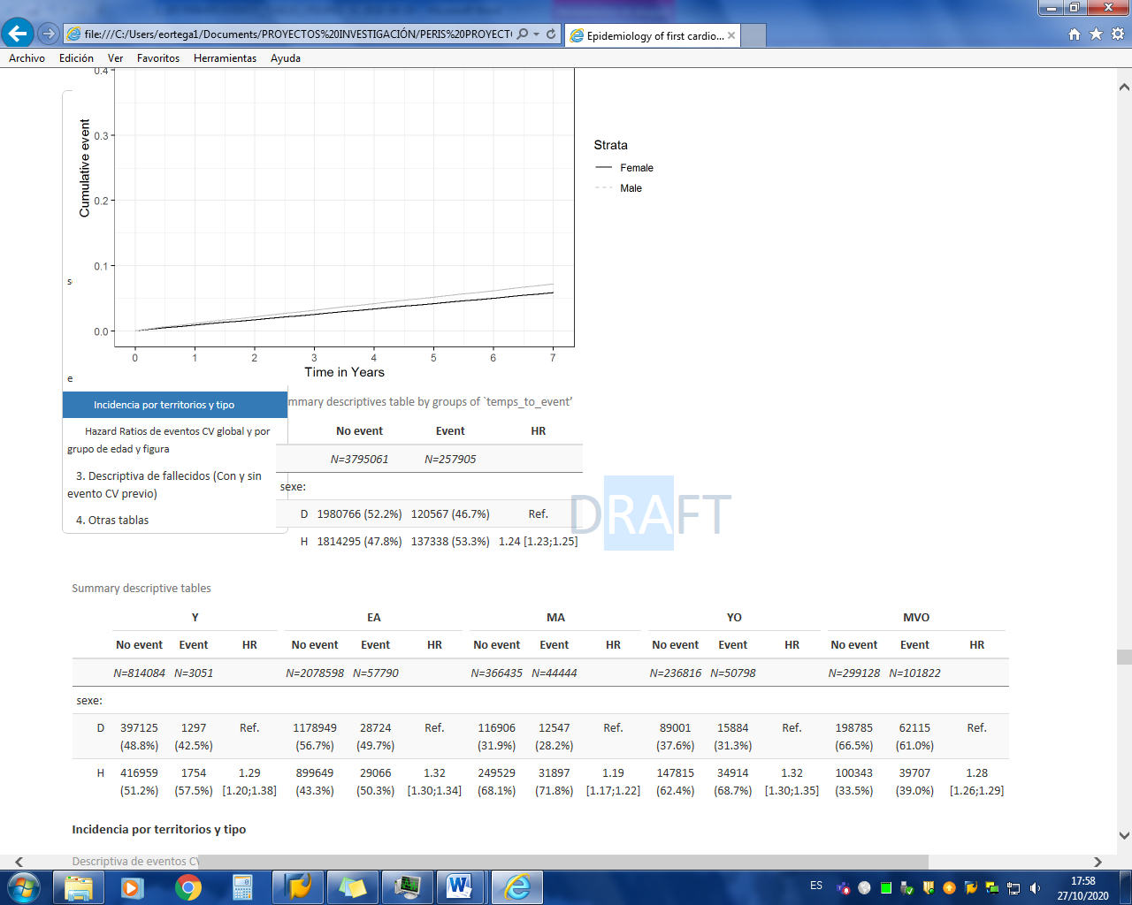

Suplemmentary Table 3. Combinar ambas tablas en una con todos y por sexos

